A ___________________ is a 4 sided polygon.

A ___________________ has two parallel pairs of opposite sides.

A ___________________ has two pairs of opposite sides parallel, and four right angles. It is also a parallelogram, since it has two pairs of parallel sides.
A ___________________ has two pairs of parallel sides, four right angles, and all four sides are equal. It is also a rectangle and a parallelogram.

A ___________________ is defined as a parallelogram with four equal sides. Is a rhombus always a rectangle? No, because a rhombus does not have 4 right angles.
____________________ only have one pair of parallel sides. It’s a type of quadrilateral that is not a parallelogram.

Rhombus Quadrilateral Square Trapezoid
Rectangle Parallelogram

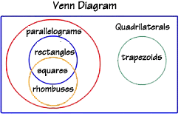

Complete the sentences by writing always, sometimes, or never.

A rhombus is ____________________ a square.

A parallelogram is ___________________ a rectangle.

A rhombus is __________________a parallelogram.

A trapezoid is ___________________ a parallelogram.

A square is ____________________ a rhombus.

True or False???
A parallelogram is never a square.
Why or why not?

A square is always a rectangle.
Why or why not?

A rhombus is never a square.
Why or why not?

A trapezoid is parallelogram.
Why or why not?

A parallelogram has one set of opposite sides.
Why or why not?

A rectangle has four right angles.
Why or why not?

A rhombus always has four equal sides.
Why or why not?

The sum of the interior angles of a quadrilateral is 180°.
Why or why not?

Classification of Triangles

Equilateral, Isosceles and Scalene
There are three special names given to triangles that tell how many sides (or angles) are equal.
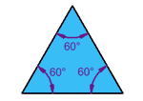 | Equilateral Triangle  Three equal sides  Three equal angles, always 60°
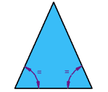 | Isosceles Triangle  Two equal sides  Two equal angles
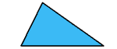 | Scalene Triangle  No equal sides  No equal angles

What Type of Angle?
Triangles can also have names that tell you what type of angle is inside:
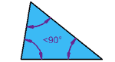 | Acute Triangle  All angles are less than 90°
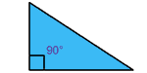 | Right Triangle  Has a right angle (90°)
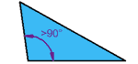 | Obtuse Triangle  Has an angle more than 90°

Draw the type of triangle described by the lengths of its sides and by the measures of its angles.
Use a ruler.

Triangle by Length of Sides
Triangle by Angle Measure |  | Scalene | Isosceles
 | Acute
 | Obtuse

Polygons

What is a polygon?

What is a regular polygon?

Types of polygons:

Name | Number of Sides
Triangle
Quadrilateral
Pentagon
Hexagon
Heptagon
Octagon
Nonagon
Decagon

Other Geometry Words to Know

Draw an example of the following words:

Name | Symbol | Definition or Example
Parallel
Perpendicular
Intersecting
Congruent
Angle

